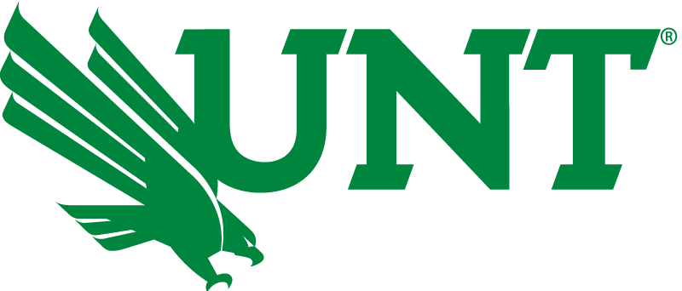
CONTACT:
Ben Jones
Media Coordinator
940-555-1234
benjaminjones@my.unt.edu

UNT is first North Texas university to provide COVID vaccines for all faculty and staff
The university rolls out the first step in its Healthy UNT campaign

(DENTON, Texas – Jan. 17, 2021) The University of North Texas will become the first North Texas university to offer COVID vaccinations to faculty and staff through its upcoming inoculation weekend. The event will take place from 8 a.m. to 5 p.m. Jan. 22-24 at Apogee Stadium, located at 1251 S. Bonnie Brae St., Denton, TX 76207. The university hopes that this event will help protect faculty and staff from COVID-19 and stop the spread of the virus.

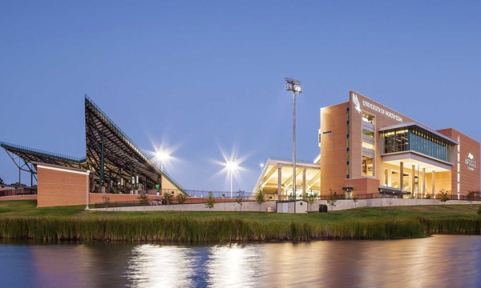
“The unique nature of COVID-19 requires that the University of North Texas vaccinates staff of all ages, not just those who are above a certain age,” said UNT President Neal Smatresk. “By offering these vaccines to faculty and staff regardless of their age, the university hopes to control the spread of the disease and ensure the health of the UNT community.”

The university will have free vaccines available for its 5,000 faculty and staff members, with the vaccines being distributed based on last names. Vaccines will be available for those whose last names start with A-H on Friday, I-P on Saturday, and Q-Z on Sunday.
Apogee Stadium is currently being transformed into a COVID-19 vaccine distribution center ahead of UNT’s Inoculation Weekend.
The second round of vaccines will be distributed the following weekend, Jan. 29-31. This event will be held at the same location following the same procedures.

“I’m grateful to the university for providing the vaccine to faculty and staff so that we can get back to business as normal,” Lecturer Rebecca Poynter said. “I’m looking forward to returning to the classroom and seeing students in person again.”

UNT has not yet announced when vaccines will be available to students. However, vaccines will be offered to its students at a later date with costs being covered by the university’s student health insurance.

For more information or questions about the event and UNT’s COVID-19 response, visit the university’s COVID response page or call the COVID hotline at 844-366-5892. Follow the hashtag #HealthyUNT on Twitter for more information as the event occurs.

###

